**Day 3 - AWS - EBS ,Snapshot Task**

Launch an EC2 instance (Linux and Windows) along with a web server. Then, create an EBS volume of 5 GB, attach it to an EC2 machine (Linux and Windows), and take a snapshot. Finally, create an EBS volume using the taken snapshot.

**Solution:-**

Creating an EC2 Instance in AWS, Instance name is **sara_server**

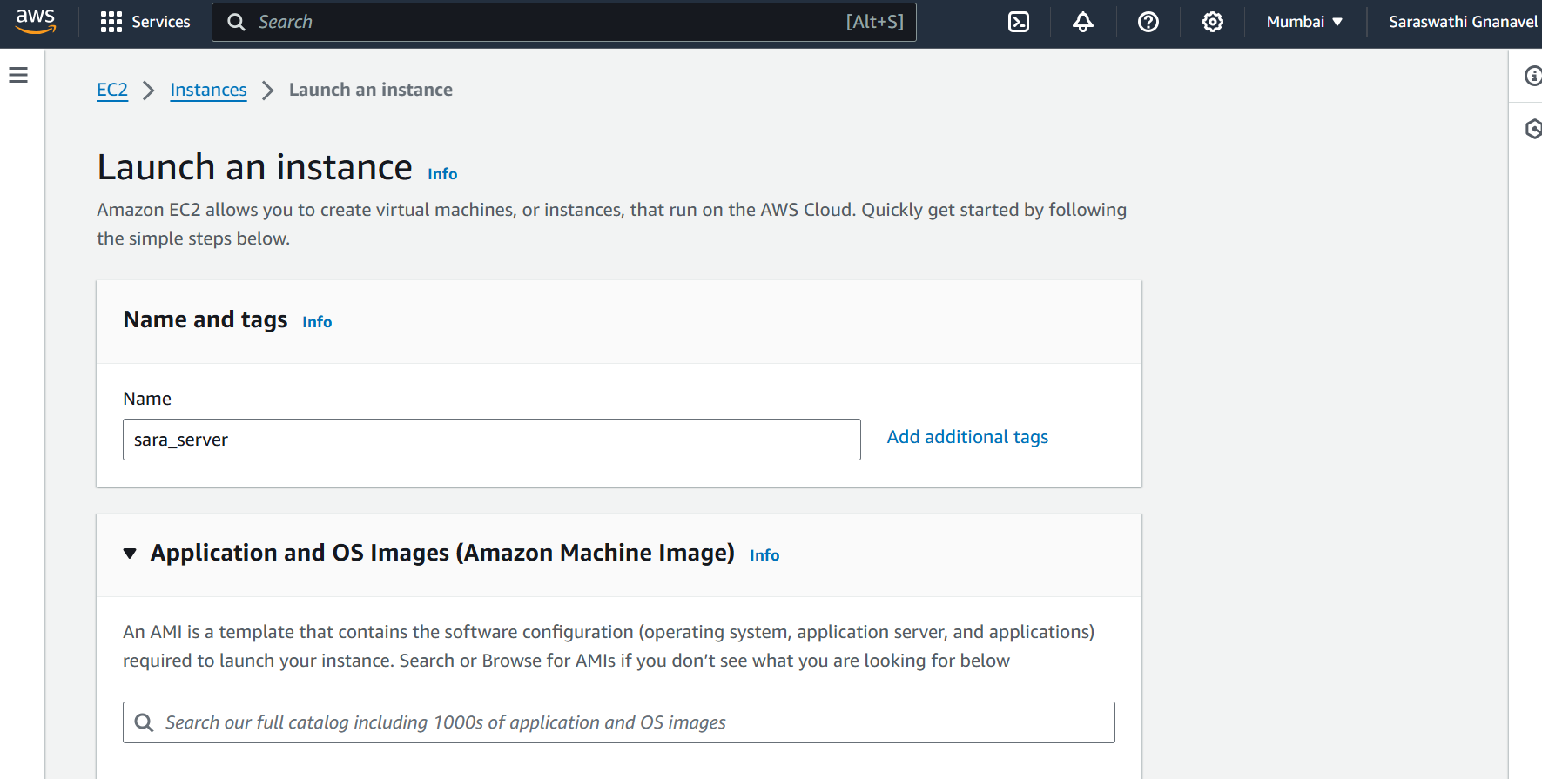

Opting Ubuntu OS

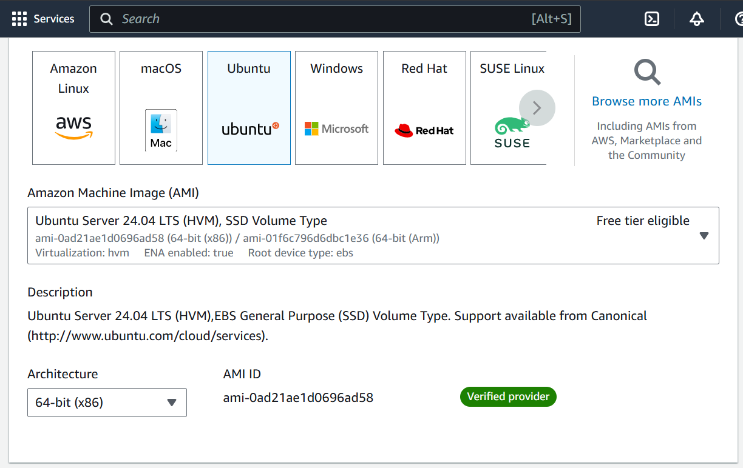

Using Free tier Instance type, Storage and going without key pair option

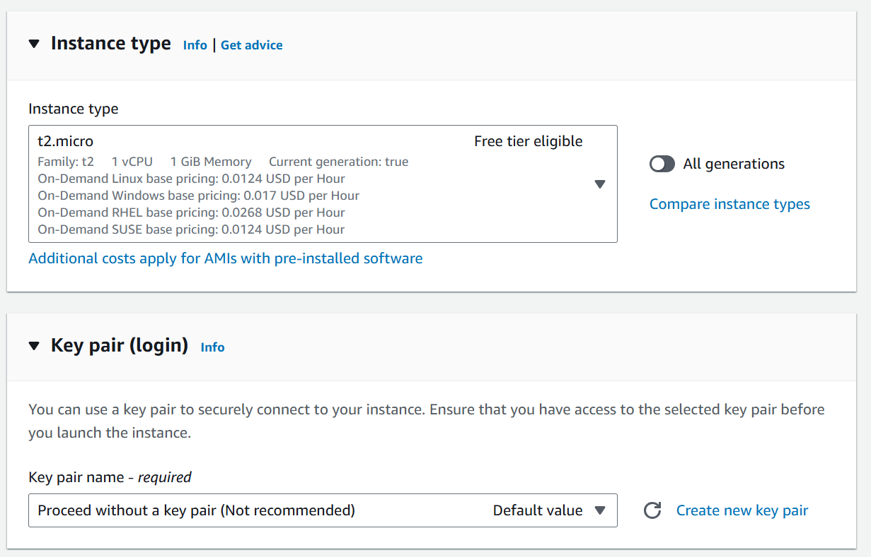

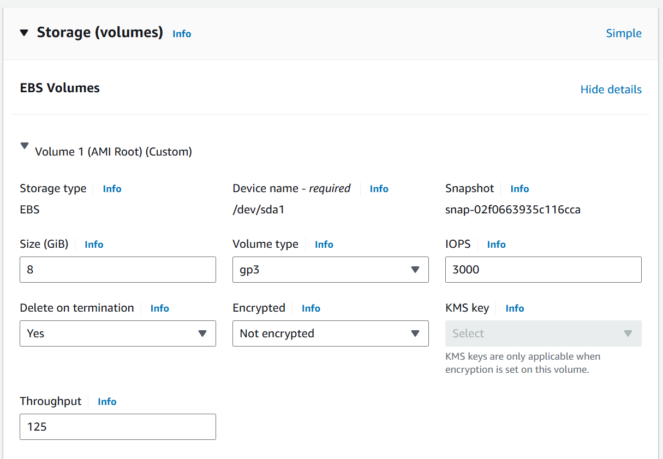

Instance created successfully

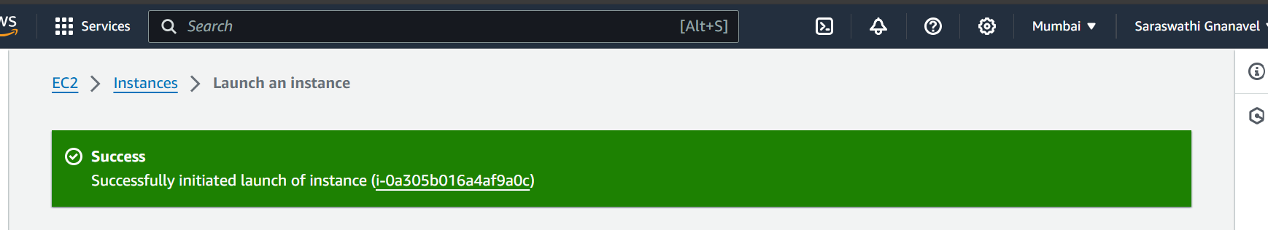

Connecting the Instance

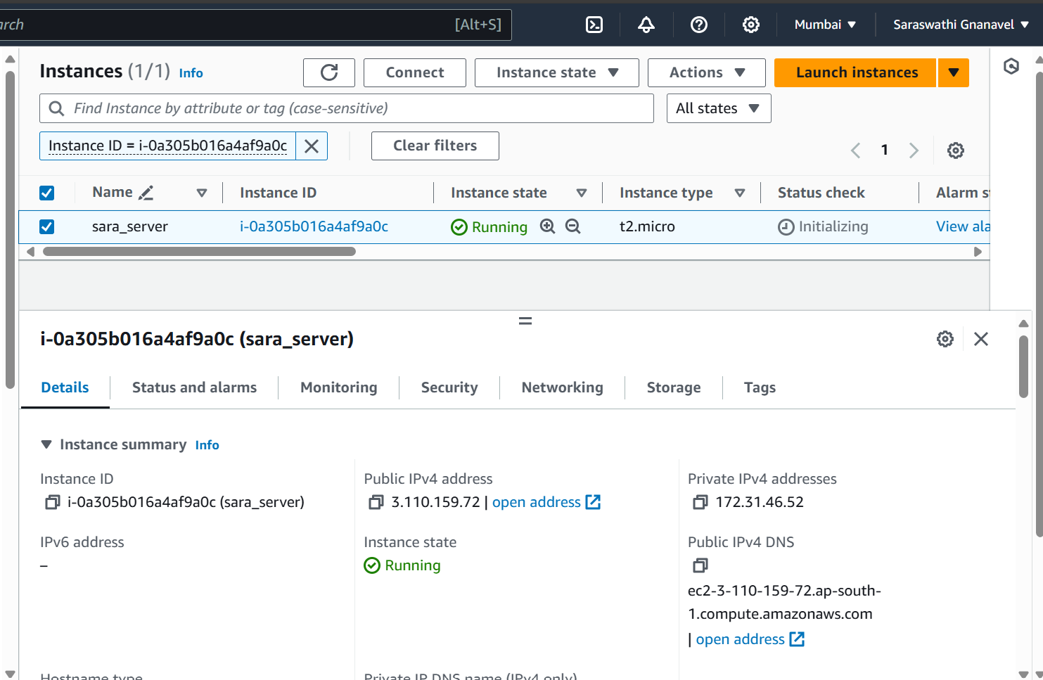

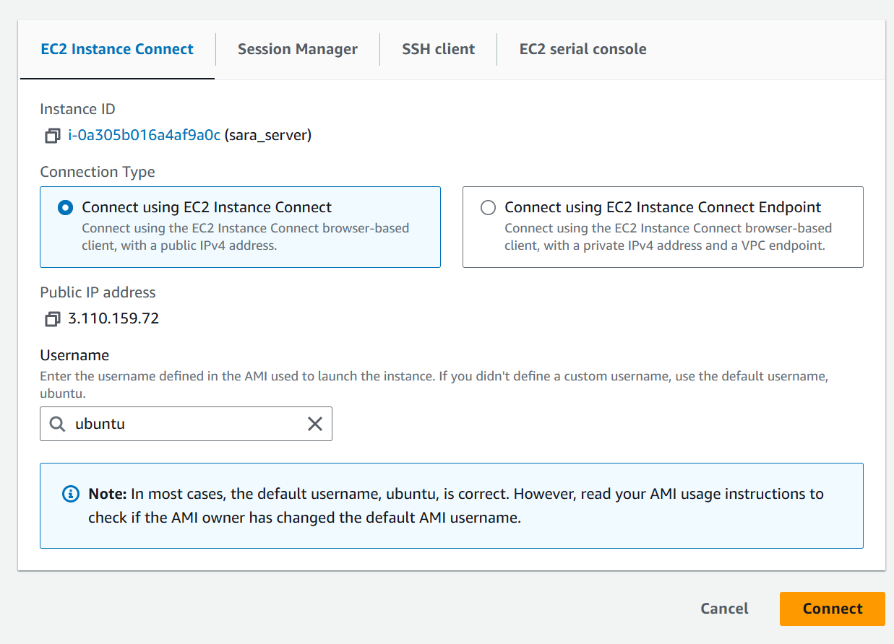

Connected with instance and created few empty files

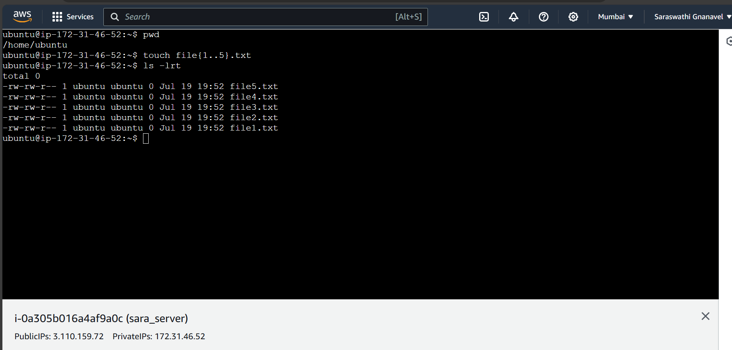

Initially sara_server has only root volume

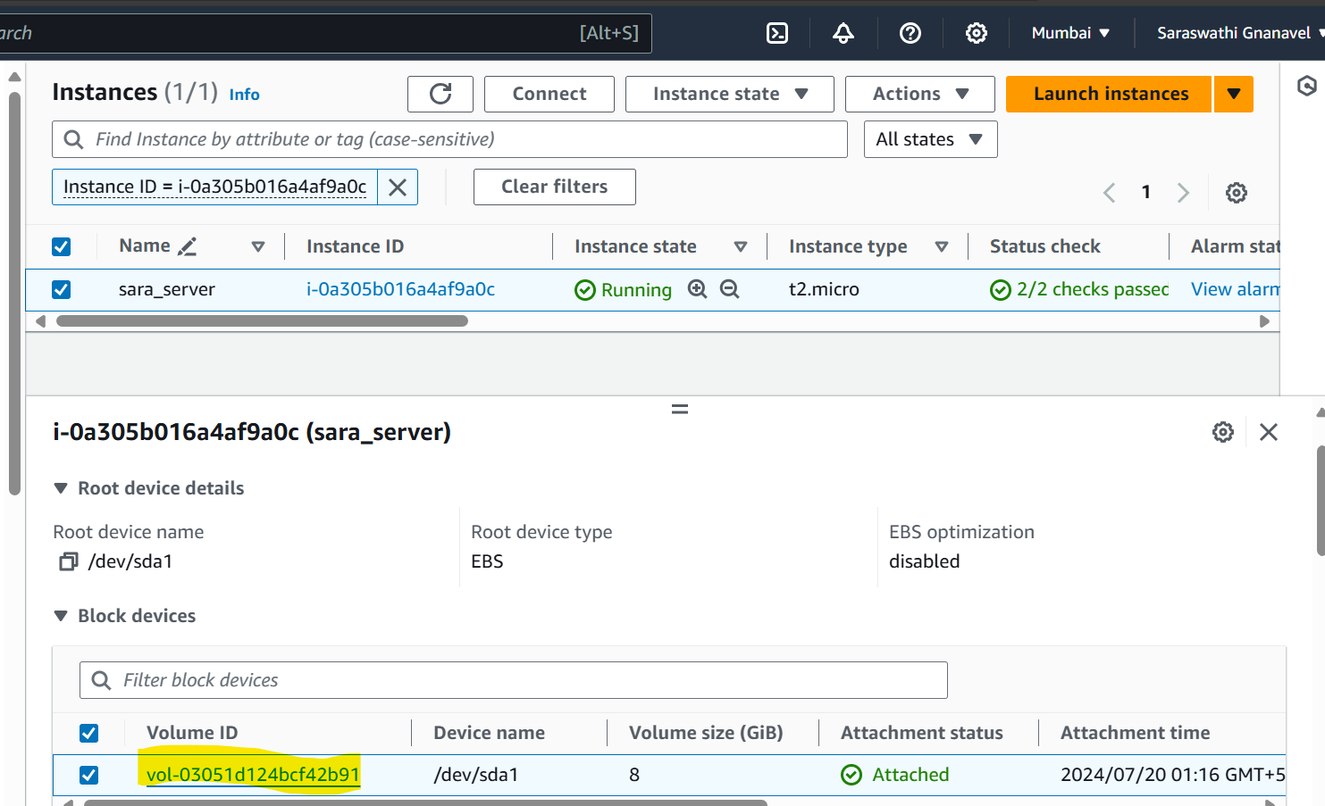

Creating an EBS volume of 5 GB

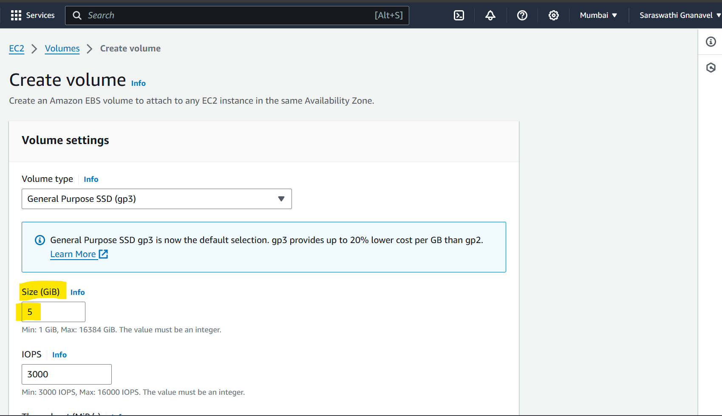

Named the volume has **Vol-2**

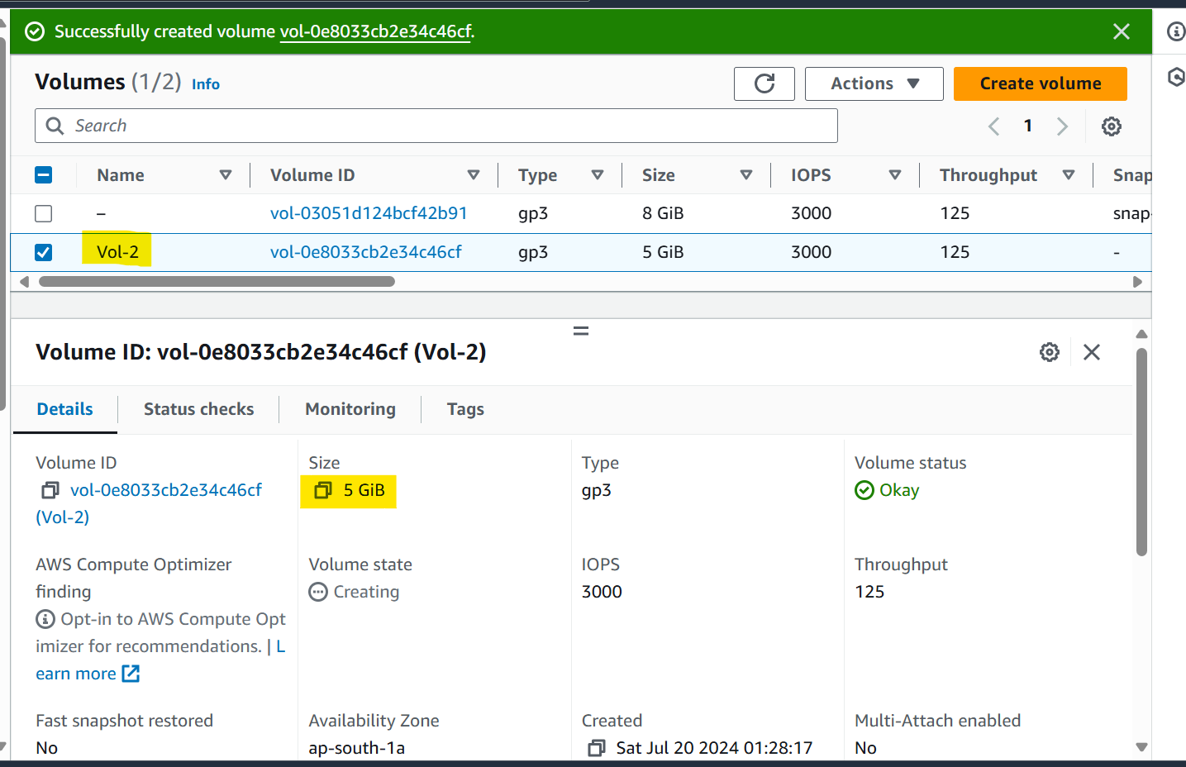

Attaching this **Vol-2** with **sara_server** Instance

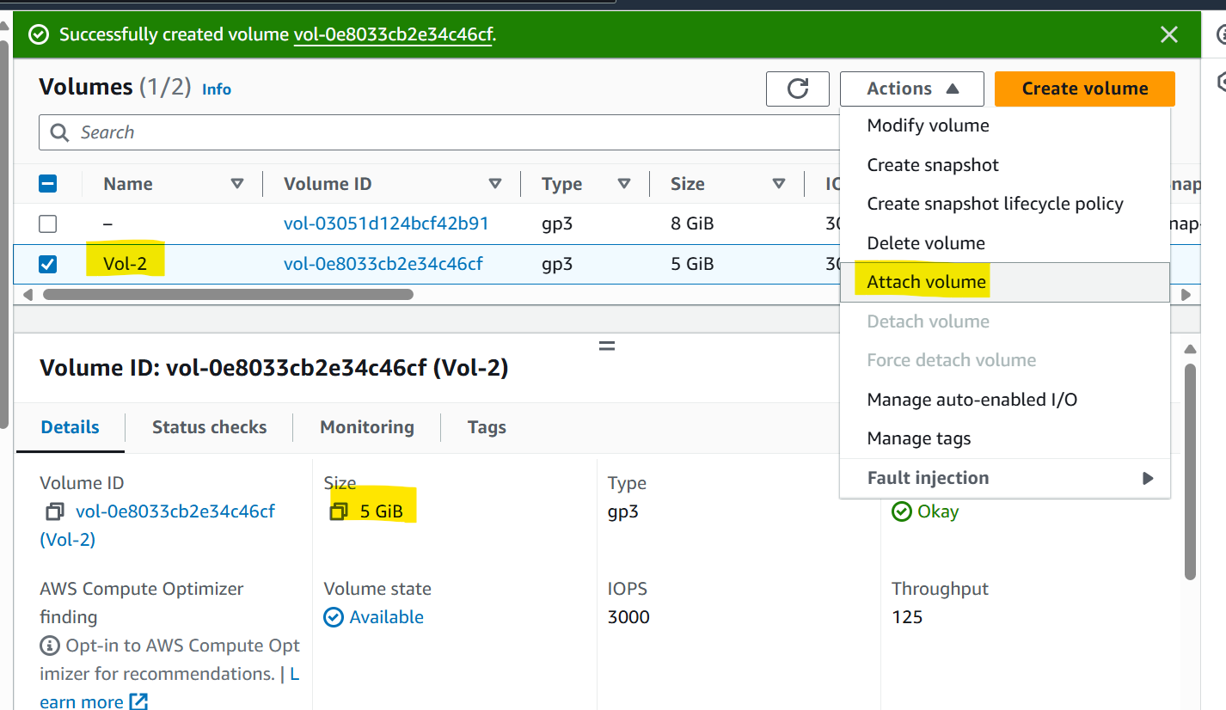

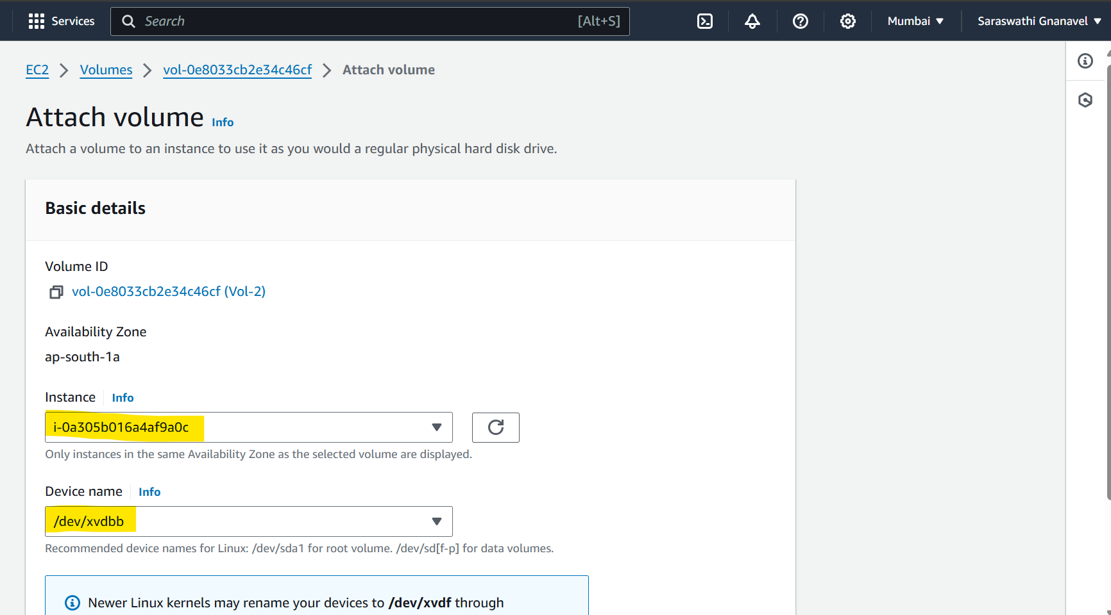

Now you can able to find Vol-2 in sara_server Instance

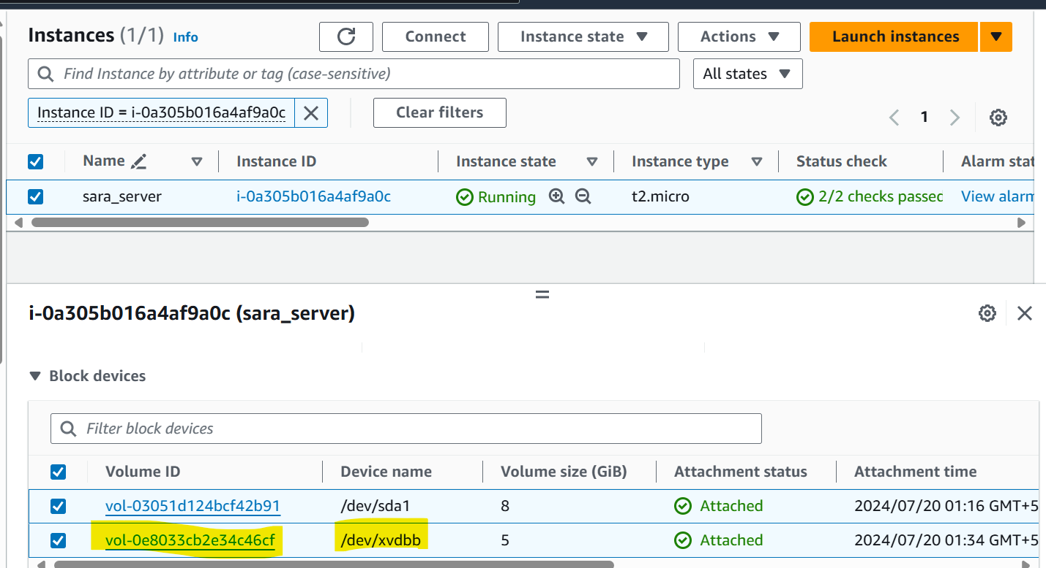

Taking Snapshot of Vol-2

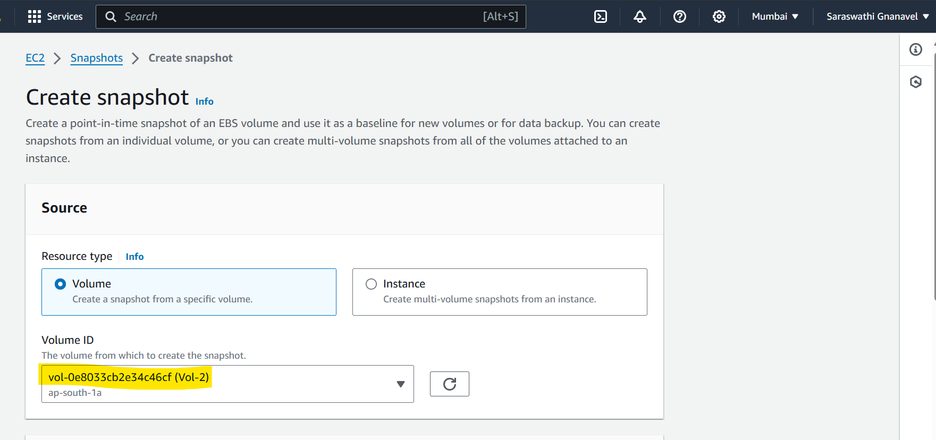

Snapshot has been taken for Vol-2

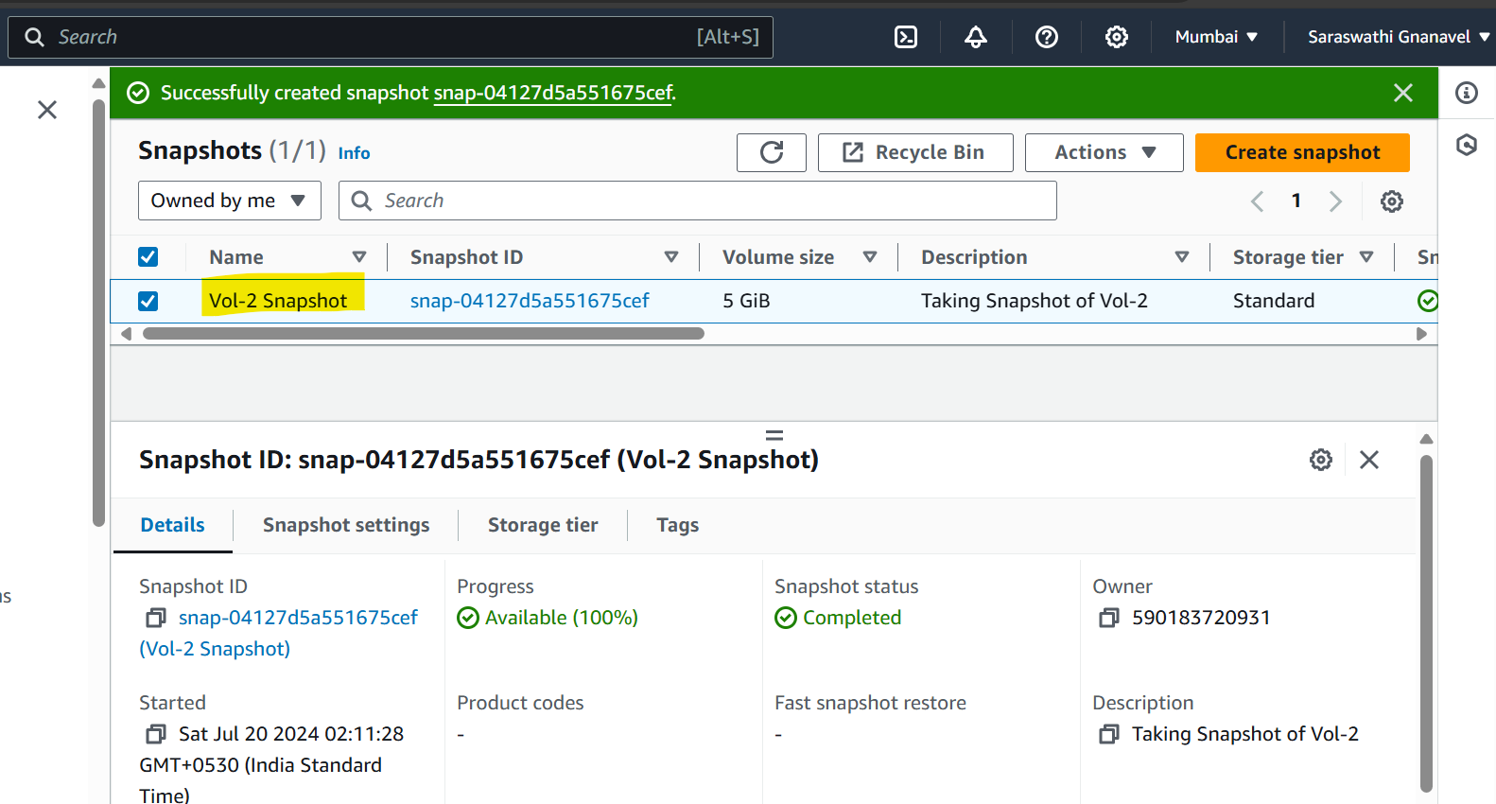

Creating an EBS volume using the taken snapshot

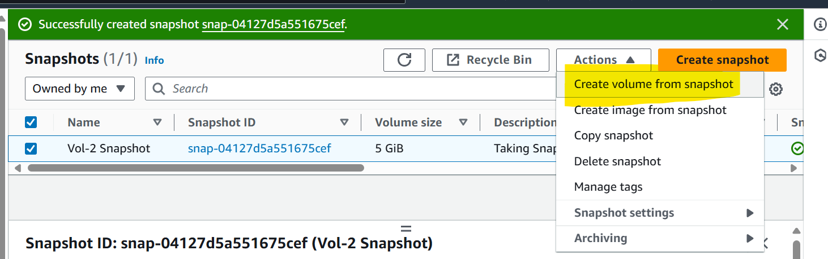

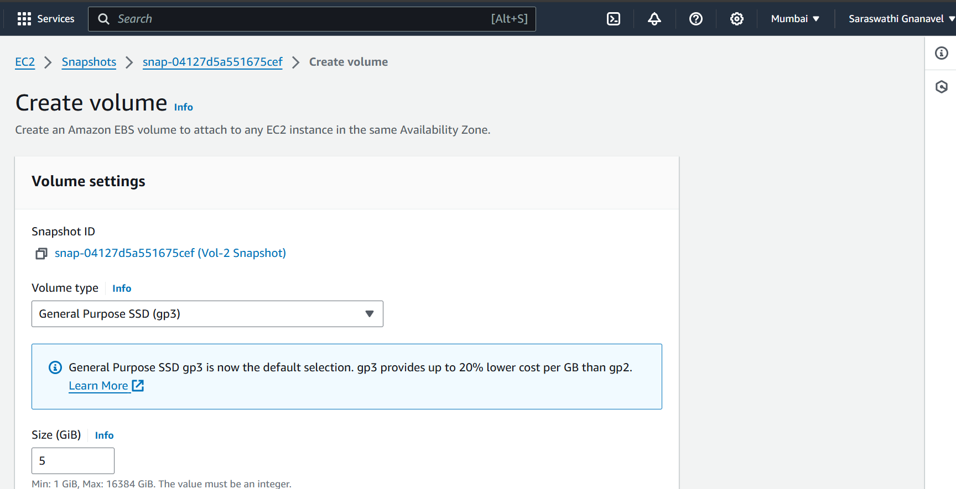

Named the volume created from snapshot as **New_volume_from_snapshot**

